I want to describe my general approach to swing trading, beginning with placing it inside the context of three general time frames that I used to govern all my trading. The three time frames have to do with how often I have to make decisions to be effective. The three categories are: monthly rebalancing, swing trading and intraday trading. I think of them as three separate and distinct environments but with some overlap between them whereby one timeframe can provide actionable information to the adjacent timeframe and provide an additional edge.
I base my long-term, monthly rebalancing strategies on the basis of research into relative strength and momentum as it relates to broad asset classes. By studying relative strength, I believe that portfolios can be positioned to take advantage of longer-term momentum.
I think of swing trading as trades that I expect to last from approximately 2 to 10 days, while the buying and selling actions of market participants create short term momentum in order to establish a new consensus fair value, when price behavior returns to normal. These opportunities appear at various times in the market and can be defined by price patterns, statistics and trade location.
I think of intraday trading as tactical, statistics-based trading that takes into account trade location, critical states, price confirmation and a realistic assessment of typical reward to risk ratios. This is a style of trading that requires self-discipline, impulse control and a healthy appreciation for the primacy of risk management.
I’ve developed systems and strategies for each of these three time frames for my own use and which I teach to others as a way to improve my own understanding of the markets. I also believe that each of these time periods has information value that can contribute to an adage in one of the other time periods.
For example, broad index ETFs that are experiencing a healthy relative strength advantage over other indices in the monthly systems can be framed as swing trades in the shorter time, when we observe a continuation of the outperformance in that shorter time frame. Similarly intraday trades that close well can often earn enough money to support a speculative overnight trade which may develop into a multi-day swing trade if the momentum carries over from day one. We call this swing trading one day at a time, and it gets funded with markets money earned from successful trades in order to protect our seed capital.
It’s fair to say then that I think of swing trading first as short-term, opportunistic, statistics-based trading which can be supplemented by information coming from the longer-term and shorter-term time frames.
It can work in the other direction as well, with some swing trades that continue to outperform the market becoming longer-term holdings because of their continued relative strength and some swing trades that can be added to intraday when they are outperforming the market in the same direction as the primary trade.
This diagram represents this idea visually:
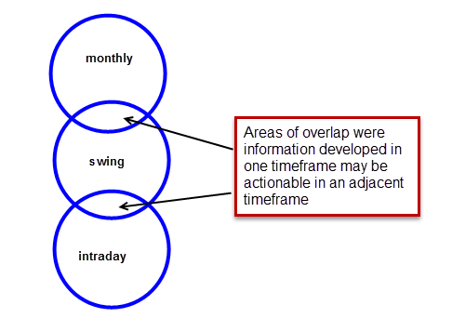
by applying the principles of effective adult education, we’ve developed accelerated learning strategies for use in our workshops that have four components:
1.workshop pre-work that contains all of the formal system descriptions and definitions needed to understand the systems at a granular level. We provide that a month ahead of time so that participants can come to the workshop with their best questions after studying the material carefully.
2.the workshop start with confirmation briefings and back briefings to ensure that we have a common understanding of the system theories before we begin our detailed hands-on practice. After reviewing rules and doing test case studies in the large group we proceed to small group and individual hands-on practice with the trade simulator.
3.the trade simulator is the hands-on practical experiential learning laboratory that allows us to manifest the rule sets through repetition and discussion. It’s in these hands-on peer -assisted case studies that we really discover a deeper understanding of the systems and strategies.
4.after the workshop, we provide a years worth of an online live and archived chat room where workshop graduates continue to develop their understanding and application of the systems in real-time trading collaboratively with other experienced traders who now have a common frame of reference. The mutual support and insight developed in this ongoing live learning laboratory really seals the deal in terms of making the information and systems your own in a way that suits your objectives and skills.

Finally, it’s useful to understand the four categories of information we provide at the swing workshop and really all of the workshops. These are: systems, strategies, techniques and tips. Briefly, we defined them and their differences as:
systems: well-defined rule-based systems that can be traded mechanically according to an objective set of rules which have been back tested, and forward traded based on evidence.
Strategies: logically consistent frameworks of beliefs and indicators that support a variety of systems from a common frame of reference and which allow a trader to apply a measured amount of discretion to sound systems. Taken together systems and strategies are a robust portfolio of ideas.
Techniques: common actions such as universal entries and exits, position sizing, risk management and market condition that apply like building blocks two different systems and strategies. Good technique helps us refine and improve our routine trading actions.
Tips: things that we have learned along the way while doing research that act is good rules of thumb and help support our risk management and opportunity finding strategies. An example is that when weekly RSI(14) drops below 30, reverses and crosses higher than 30 you should be especially alert to what may have just been an important intermediate-term market low which can support long-term long side swing trading in the broad market. Do your own due diligence before you take action.
In summary then, I see swing trading is a reasonable approach to market trading in a manageable time frame that allows and of day traders and weekend traders to take advantage of persistent and repeating opportunities in which can support longer-term and shorter-term trading objectives. We think our package of educational and support materials are an effective way to rapidly develop skills in these areas and we would invite you to explore these ideas with us. Thanks for your attention and interest!

