TORTOISE CAPITAL MANAGEMENT
The Quick Frog
AN Intraday trading strategy
A rules based intra-day trading strategy (ver 1.01)
Ken Long
July 29, 2012

An intraday rule-based system that targets large-cap stocks and liquid ETFs that are most likely to have large intraday-trending moves relative to their volatility. The system can go long or short. It makes entry decisions 60 minutes after the market open and uses the standard deviation of the range of the last 30 days to define decision-points based on price. A few simple exit rule variations allow the trader to refine the system objectives. The system should have a win rate > .5, should never take a greater than 1R loss, and is open to the possibility of wins > 1R.

Disclaimer:
* Please remember that these stock screening services are for educational purposes to show possible tactics that can be used in the markets. Trading stocks has significant profit potential and also carries a significant risk of loss. You are responsible for your own trading decisions! Obviously, you are responsible for your own trading results and individual results vary. The information contained here is believed to be accurate, but no claims or warranties implied or otherwise are made pertaining to the accuracy of this information and we are not responsible for errors or omissions. There is a very high degree of risk involved in stock trading. Posted past results are hypothetical trades. Results do not reflect slippage, commissions and other market risk factors inherent in actual trades in the stock market. Past results are not indicative of future performance. Tortoise Capital Management., Ken Long, or anyone affiliated with this educational screening assume no responsibilities for your trading results. Tortoise Capital Management, Inc., Ken Long, or anyone affiliated with this educational screening, including friends and relatives, may or may not take a position or have a position in these stocks, based on their trading discretion at the time. You should assume that these positions may be substantial enough to be material. We will not intentionally scalp or front run on any recommendations; The strategies, lessons and all other features are for educational purposes only and should not be construed as investment or trading advice. Tortoise Capital Management, and Ken Long are not offering professional trading advice in this educational service. You must assess the risk of any trade with your broker or financial professional and make your own independent decisions regarding any trades. Copyright 2011 Tortoise Capital Management, Inc. All Rights Reserved. Protected by copyright laws of the United States and international treaties. This newsletter, e-letter, or promotional material may only be used pursuant to the subscription agreement and any reproduction, copying, or redistribution (electronic or otherwise, including on the world wide web) in whole or in part, is strictly prohibited without the express written permission of Tortoise Capital Management, Inc.
System Name: “The Quick Frog”
  - Version: 1.0
  - Date of last update: July 29, 2012
  - Note: this system is identical to the “Slowfrog” which waits 60 minutes from the Open before an entry can be made, and the “Leapfrog” which is not required to wait ANY amount of time before entering.

- System description: An intraday rule-based system that targets large-cap stocks and liquid ETFs that are most likely to have large intraday-trending moves relative to their volatility. The system can go long or short. It makes entry decisions 30 minutes after the market open and uses the standard deviation of the range of the last 30 days to define decision-points based on price. A few simple exit rule variations allow the trader to refine the system objectives. The system should have a win rate > .5, should never take a greater than 1R loss, and is open to the possibility of wins > 1R.

- System logic, concepts and definitions:
  - Frogs jump; their normal distance can be described, the direction is problematic.
  - We can describe their normal and exceptional jumps using basic statistics
  - Recent price action (last 30 days) is the best reference to define normal price action
  - Intraday range statistics should be the focus of intraday traders, in order to filter out overnight price behavior
  - 30 data points are the minimum sample size to apply descriptive statistics with enough confidence to trade statistically
  - The AverageRange is a reasonable description of normal price behavior
  - The standard deviation of range is a reasonable description of noise
  - The size and direction of the gap do not have predictive value of the direction of the subsequent follow-thru
  - The size of the gap is correlated to the size of the follow-thru
  - A directional move > 1SD is the smallest move that can be described as a directional move
  - A directional move < 1SD can be described as “noise”.
  - The relationship between Average Range and its volatility can be used to classify the relative intraday opportunity available in a population of targets. We can call it the “Frog Quality Number” or FQN, and think of it as a measure of “froggishness”.
  - The high of the day (HOD) and low of the day (LOD) are important price points that represent support and resistance levels as the day proceeds.
  - The Open is simultaneously the HOD and LOD at that moment, until price begins to move.
  - The price action in the first 30 minutes can seem chaotic; price after the first 30 minutes is often more directional and less volatile (ie more trending).
  - Managing trades on 1,3 or 5 min charts is manageable for a simple ruleset
  - Market conditions for longer time frames are not necessary.
  - Intraday frog techniques can be coupled with swing trade system signals when the trader can expect more directionality than usual.

- Targetted stocks/ETFs/markets:
  - Large cap stocks: in priority: Dow30, S&P 100, S&P500, large cap ADRs on NYSE
  - Liquid ETFs, in priority: ETF30, ETF100…

- Historical performance:
  - Pending final Tradestation coding to conduct deep backtesting
  - Forward testing with prototype and production level of risk is very favorable for win rates, risk control, exit flexibility, and frequency of opportunity
  - The 30 min waiting period is more conservative than the “Leapfrog”, but more aggressive than the “Slowfrog”. It is a good 2nd step to approaching a systematic application of the ruleset to individual psychology and performance. Start with Slowfrog, progress to Quickfrog when ready.
  - Because intraday trends are often well established by the 30 minute mark, it is reasonable to put a high priority on securing the first 1R of profit; exiting the full position at 1R and/or raising the stop to lock in 1R has a lot to recommend it.

- Setups/Filters:
  - Calculate the FQN for all members of the sample population, using the formula: AvgDailyRange(30) / StDev(30)
  - Focus intraday attention to the targets with the highest FQN value, to create trade frames with the targets that have the highest expected reward: risk ratios
  - Wait for 30 min after the open to make an entry decision
  - Evaluate the “froggish” candidates to select the most directional target to enter

- Entry rules: There are 2 conditions: (1) the target has not moved more than 1SD from the high or low of the day (HOD/LOD) in the first 30 min, and (2) the target has already moved more than 1SD from HOD/LOD in the 1st 30 min.
  - When the target has not yet moved 1SD from either the HOD or LOD, at the 30 minute mark, take the first entry opportunity to go long or short
    - Go long when price > LOD +1SD, with an initial stop at LOD
    - Go short when price <HOD -1SD, with an initial stop at HOD
  - When the target has moved more than 1SD from the HOD/LOD, and is still more than 1SD from the opening. Now you must examine current price action:
    - If price is going in the same direction as the >+1SD move when it crosses the 30 min mark, you can go long/short in that direction with a 1SD stop.
    - If price has reversed from the HOD/LOD you will go in the direction price is moving when it has moved 1SD from the HOD/LOD.
    - If price is moving sideways, simply wait until it has committed one way or the other, as defined by 2 candles in the same direction, taking the breakout of the 2d candle as the signal (see example diagram)

- Trade management & Exit rules:
  - When the trade makes +1R, exit half the position and move the 2nd half to lock in +.5R.
  - When the trade makes 1.5R on the 2nd half position, trail with 1R (ie 1SD)
  - Exit the position not later than 30 min before the close

- Position sizing rules:
  - Determine your risk allocation % per position
  - Calculate the dollars to risk per trade
  - Calculate your position size for each target using the formula:
    - (Risk Dollars / SD) = #shares or contracts

- Re-entry rules:
  - If the initial stop has been hit, then by definition it has just made a “non-noise” directional move, and you can stop and reverse.
  - If you are using the optional trailing stop, then the stop and reverse will occur before you have experienced a full 1R loss in the first position.
  - Take up to 3 tries in a day on a symbol

- Optional decisions/rules:
  - Consider making the iStop a trailing stop instead of a static stop. In this case the worst exit you can have is -1R, which only happens if the trade moves 1SD against you immediately after entry
  - Consider a small buffer in addition to the SD iStop
  - If there are not 2SD remaining until the AvgRange for the day is hit, consider not taking the entry.
  - Take the entire position off at 1R and make bank
  - If price is moving in your favor thru 1R, wait until it pulls back 1 candle before taking half and adjusting your stop
  - After exiting a trade, look for opportunities to make follow on trades, using a lens of SD to frame trades (advanced discretionary techniques)
  - Consider adding a position when the trade makes new HOD & LOD
  - Consider adding a position when the trade breaks thru yesterday’s high or low
  - Combine this strategy with reliable swing system signals to get favorable entries
  - Consider trailing stops, instead of “flat” stops using a ratchet
  - If price is moving in your favor 30 min before the close, consider staying in a little longer to get more juice from the berry; beware sharp end of day reversals.

- Preferred brokers: low cost transaction per share is the most important decision criteria for this system. If you are an intraday trader trying for more, then consider slippage and speed of execution as well. Any large deep discount broker should satisfy these requirements.

- How to start the portfolio from all cash: use money from your total portfolio that is allocated for equity exposure and begin.

- The Appendices give examples and concept descriptions of the Slowfrog, Quickfrog and Leapfrog strategies

Appendix 1: Slowfrog example trade:
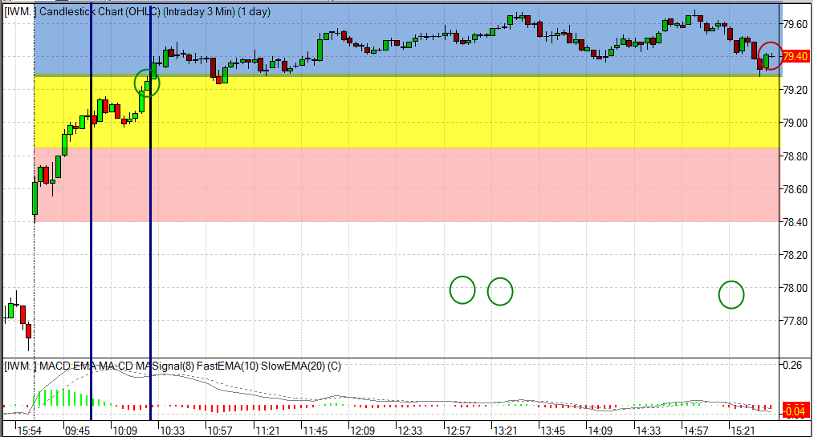

Trade moves 2 full SD off the LOD and the trader enters at 79.30
You can also see the Quickfrog on the same chart at the first blue line which s a more favorable trade in this instance
Appendix 2: a Slow frog long, then a reversal to the short side intraday
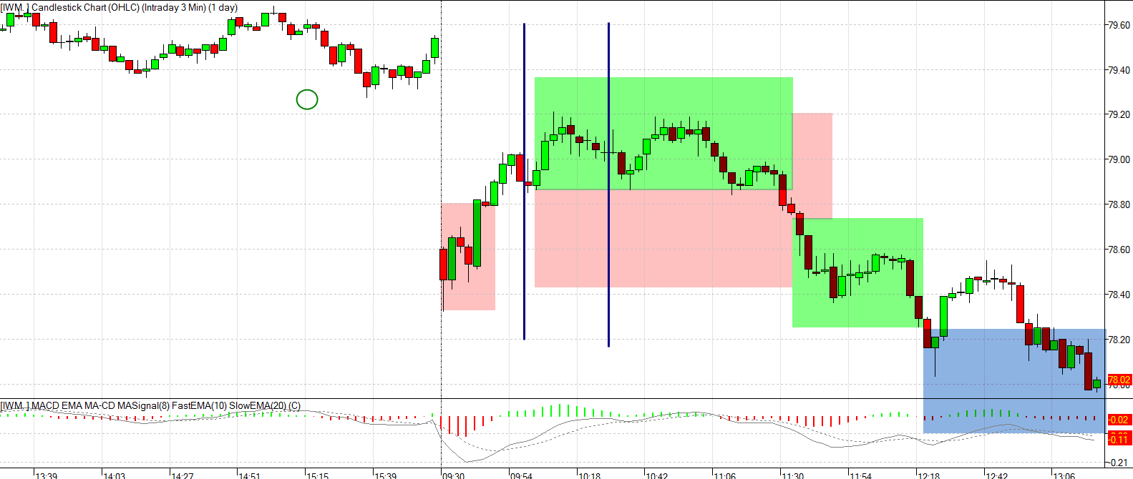
Appendix 3: example of a delayed slow frog: VXX stays in the 1SD channel for a long time before breaking out

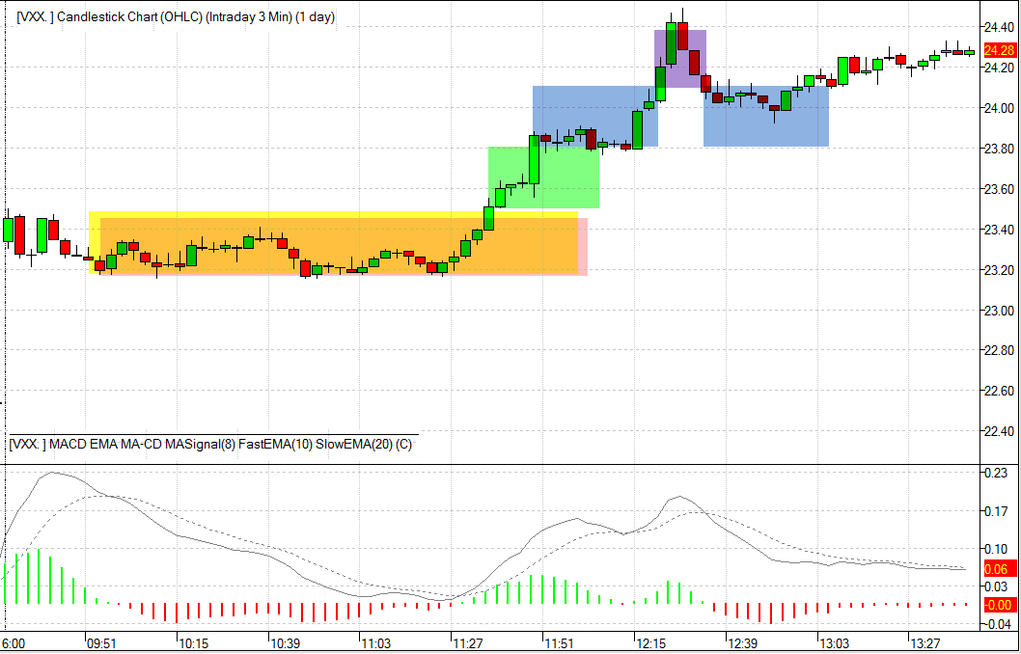
Appendix 4: a typical slow frog trade in IWM, nets about .9 R. The early moves make it tempting to master the slowfrog quickly in order to participate in quick frog (wait 30 min) and leapfrog (pounce on the first SD move and go)

Patience; these trades are always available.

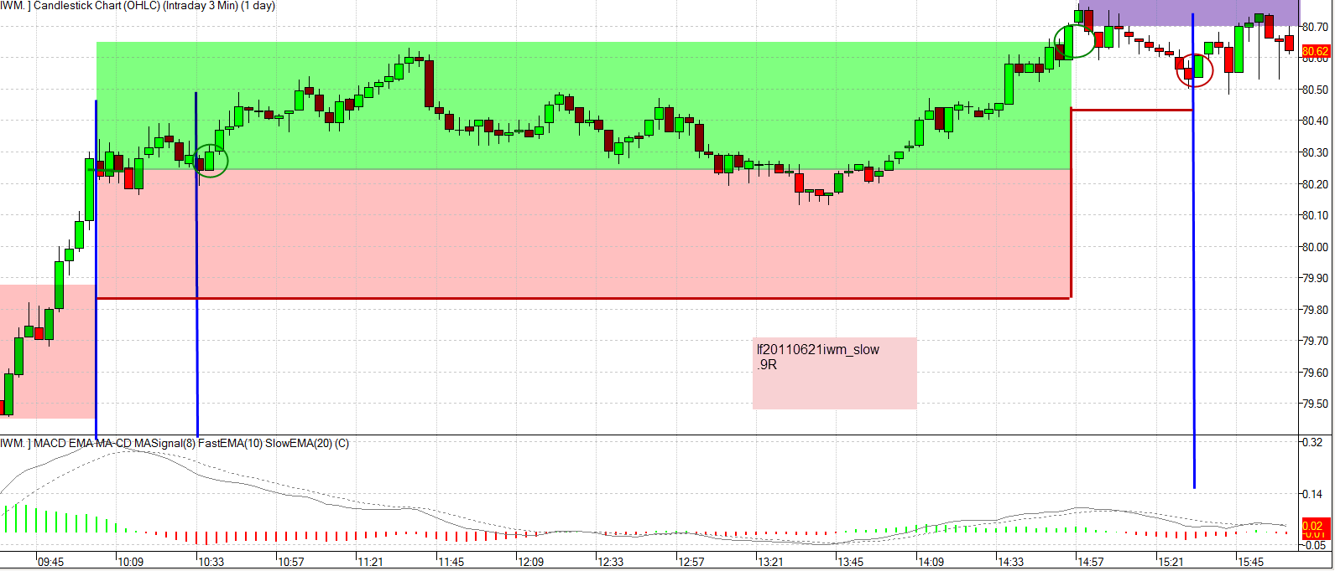
Appendix 5: detailed frog example:
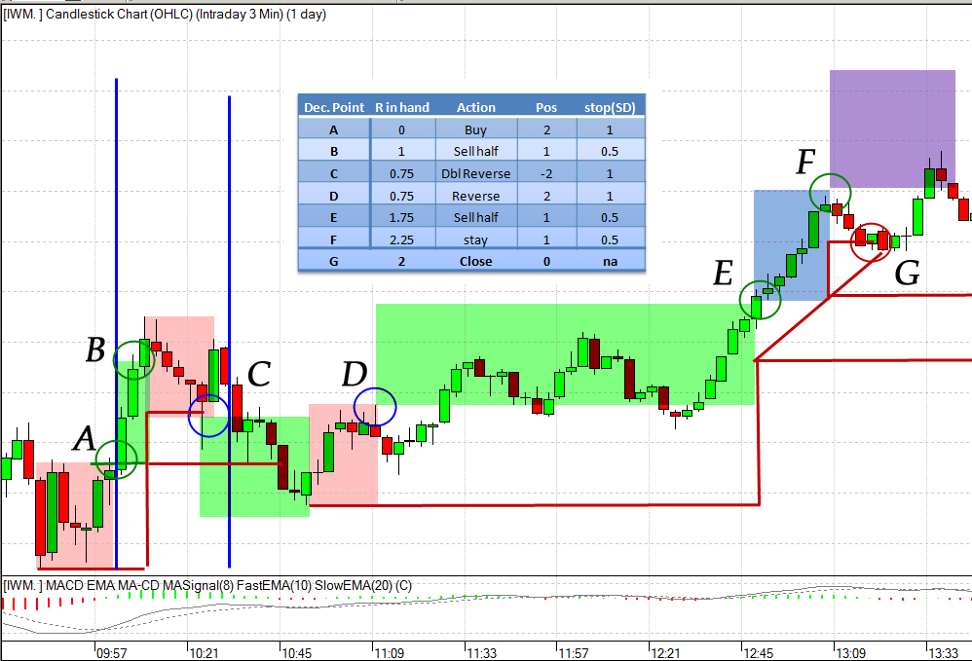

Appendix 6: complex example of leap frog, quickfrog & slow frog,

XLU makes a 3SD move up from the open, a 3SD move down, then slides for another 4SD down. Huge opportunities on that day for multiple types of frog trading

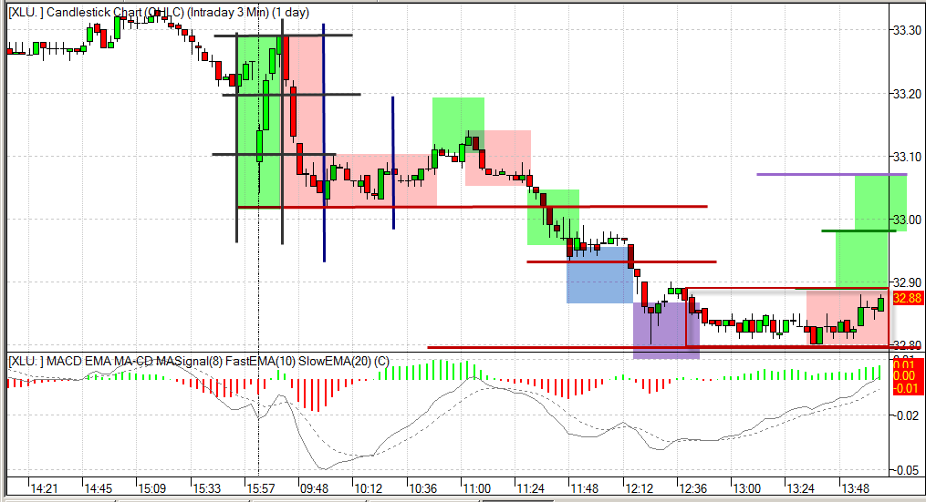
Appendix 7: 2 frog entry ideas:

After identifying a rebound off the current LOD, the trader hypothesizes that this may actually BE the LOD and frames a trade:

Entry A: the trader front runs the full SD bounce off the LOD, and enters on momentum (in this case defined as 2 white candles, with the entry being a breakout of the high of the 2d candle, with a stop of 1SD, which in this case is below the current LOD)

Entry B: the trader enters when price has moved a full SD off the LOD, with an iStop of the LOD. The trader pays for more confirmation
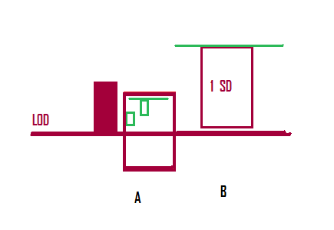
Appendix 8: frog entries during the day

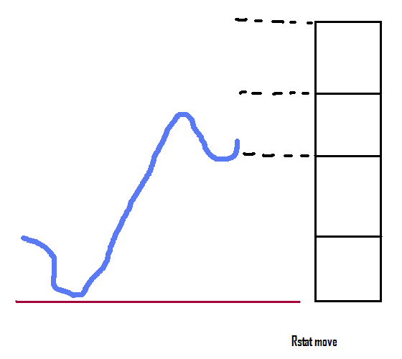
The trader observes an LOD at the redline, and knows that the Rangestat for the day is approx. 4SD (Rangestat = AvgRange + 1SD).

He observes that the original move off the LOD went almost 3 SD, and pulled back at the LOD +2Sd price level and is starting to move back up.

He may or may not have traded the first leg. He may have traded it and still have the position open.

The trader could elect to take the entry now, hypothesizing the pullback has formed a support level, and by using a 1SD stop, and a reasonable target of 2Sd more still available, has identified a 2:1 reward:risk ratio.

This is an example of using an “SD lens” to frame intraday trades.
Appendix 9: preparing a frog trade combined with a swing trade setup

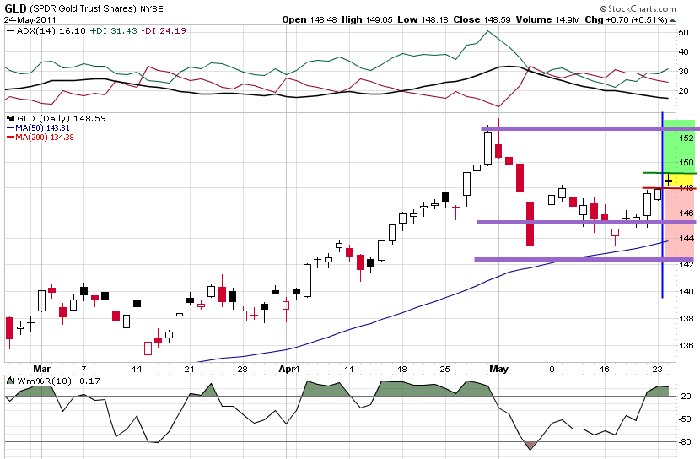

The trader identifies a favorable swing trade pattern in GLD which also, on that day had a high Frog Quality Number (FQN). The swing trade frame identifies price levels that confirm the swing trade frame is working favorably;

The intraday frog technique may allow an even earlier entry into what can develop into a power swing trade.

The combination of intraday frog + swing trade frames is a powerful way to large positions in favorable trades based on positive price action.

This swing trade frame works equally well to the short side if price fails thru the red line at 148.

This is an ideal case for scenario trading based on the market’s ability to go in either direction
Appendix10: example of an intraday frog trade off the hypothetical LOD in symbol PFE

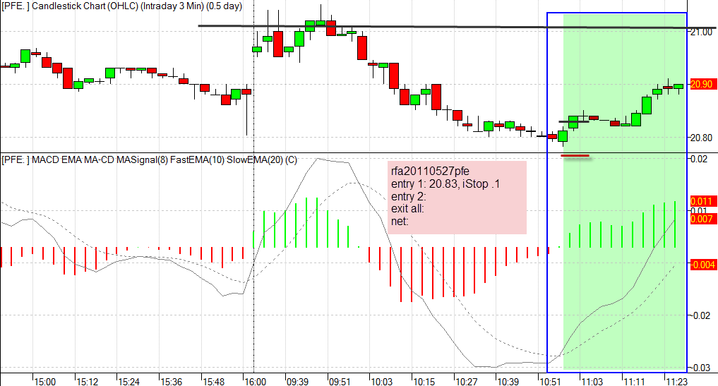
Appendix 11: an example of leapfrog (early entry) and a slow frog entry in EWZ

The entry at 73.40 reflects a slow frog, waiting fro a full SD move off the LOD. The earlier green circle at 10Am at 73.20 is an example of the “Quickfrog” entering at 73.20

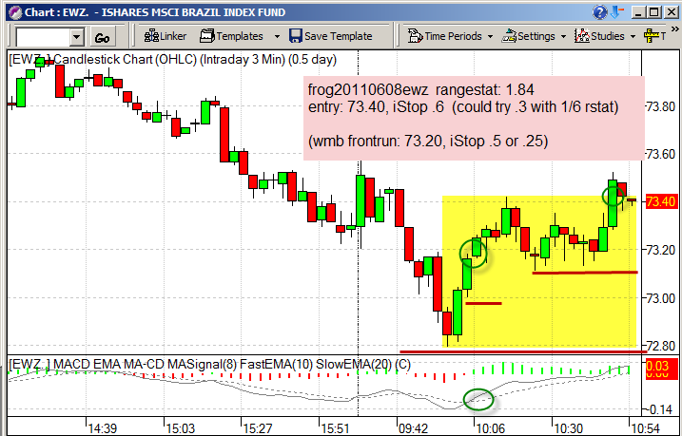
Same idea in IWM
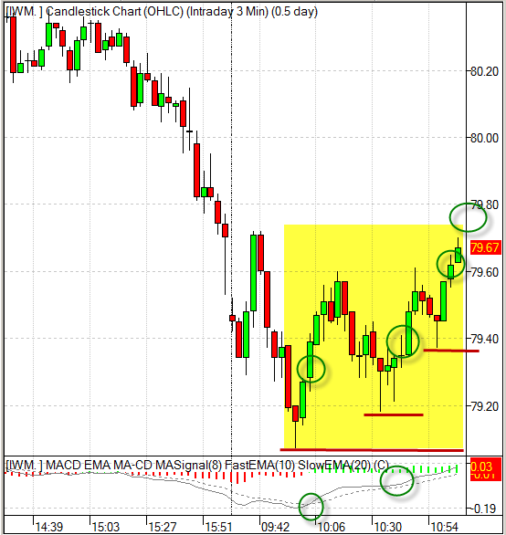
Appendix 12:

For more info, contact Ken Long at

longke@yahoo.com

traders are routinely and professionally capturing multiple Rs a day using this low risk, rules based strategy

