Memo for: Record
Subject: Market classification system (IP007)
Date: 17 Sep 10
Author: Ken Long

- I classify the market (SPY) in 2 dimensions:
  - Price: compared to the 200d MA
  - Volatility: comparing today’s ATR% to the last 100
- Price dimension: Bull, Sideways or Bear
  - Bull: Price is more than 2% > 200d MA
  - Sideways: Price is within +/- 2% of the 200d MA
  - Bear: Price is more than 2% below the 200d MA
- Volatility: Volatile, Normal, Quiet
  - Volatile: today’s ATR% is more than 1 StDev higher than the average ATR% of the last 100 days
  - Normal: today’s ATR% is within +/- 1 StDev of the average ATR% of the last 100 days
  - Quiet: today’s ATR% is more than 1 StDev less than the average ATR% of the last 100 days
- This creates 9 potential market states (see chart below):
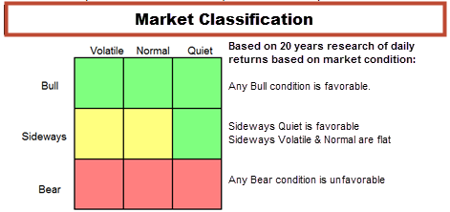

- Based on this classification system and a test period of the last 16 years:
  - Tomorrow, on average, is favorable when today’s market condition is any Bull or Sideways Quiet
  - Tomorrow, on average is flat when today’s market condition is Sideways Volatile or Sideways Neutral.
  - Tomorrow , on average, is down when today’s market condition is any Bear.

